Scenario and use case for Travel Alone

Team 8

Member:

12301103 SongLiu（刘嵩）

12301107 JunmengWang(王俊猛)

12301097 SitengGuo（郭斯滕）

## Scenario for Travel alone

### First scenario in diagram.

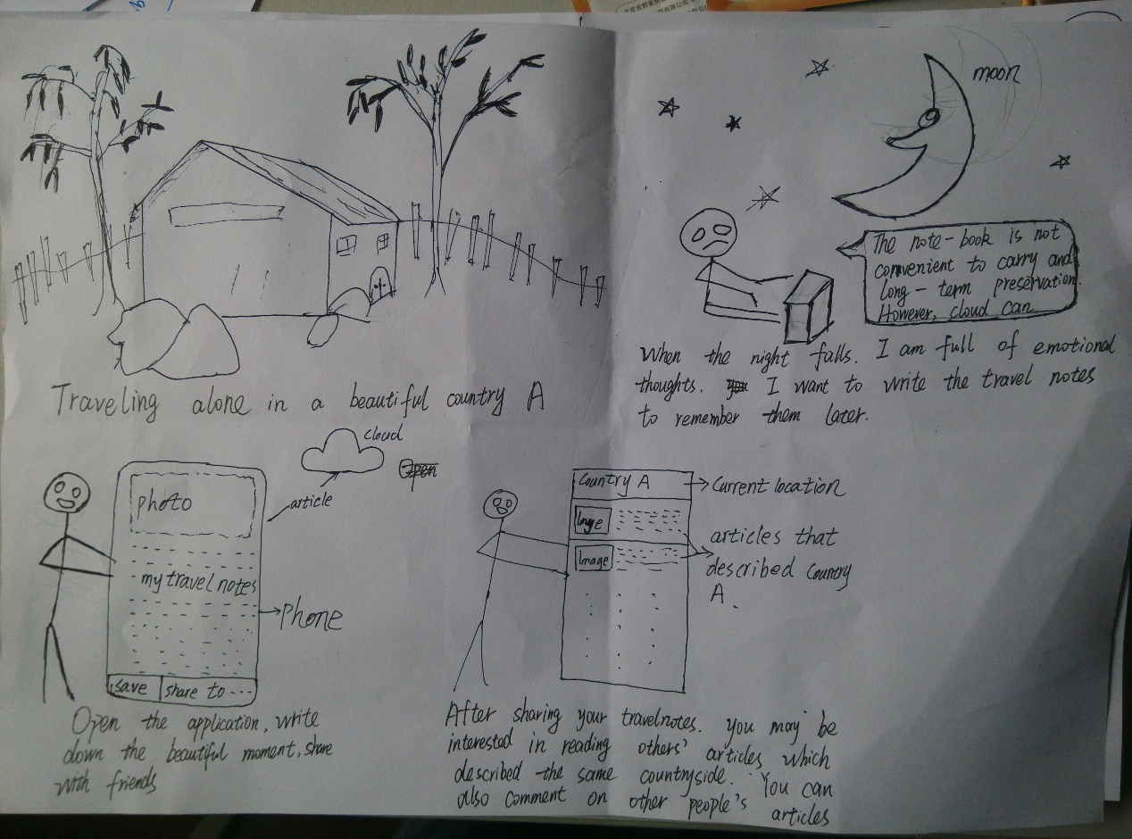

### First scenario in text.

Before

Jobs is traveling alone in a beautiful countryside A, and he enjoys the trip. When the night falls, he looks back the wonderful day, he want to write an article to record it. While he doesn’t want to write it on paper, because paper is not convenient to keep and share with friends.

During

Jobs opens an application installed on his mobile phone and write his article on it. Then he shares his article to his friends. After that he reads articles written by other travelers.

### Second scenario in diagram.

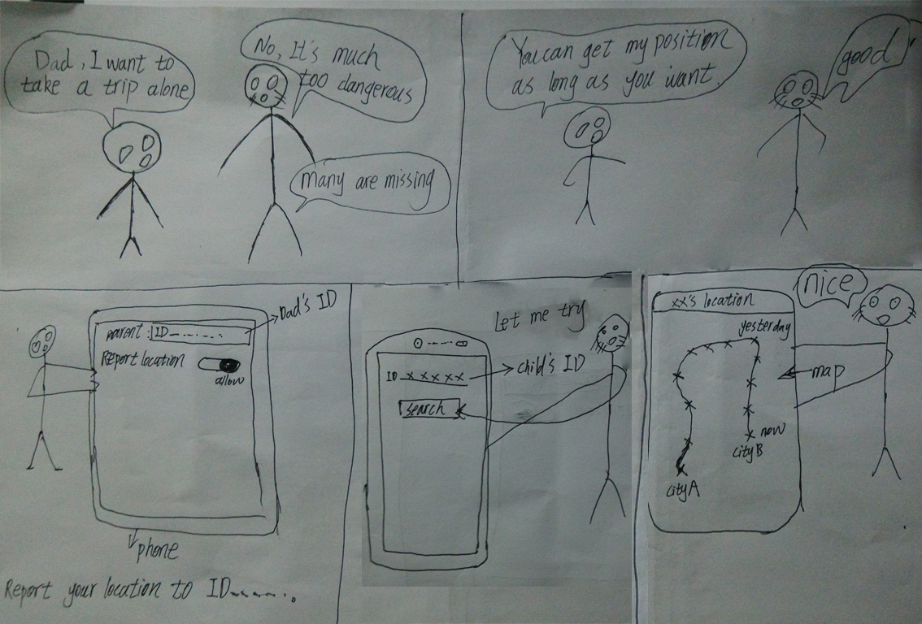

### Second scenario in text.

Before

Child: dad, I want to take a trip alone.

Dad: No, it’s much too dangerous. Many are lost.

Child: dad, you can get my location as long as you wish.

Dad: how would I?

During

Child take out his mobile phone, open Travel alone application. Then he allow the application to report his position to his dad.

Dad open application then search his son’s position.

After

The application show child’s recent activity position in a map. Dad very like this function and allowed his son’s request.

## Use Case for Travel Alone

Use Case 1 - Enable GPS function

Precondition - none

Description - When the user start the app, show a message box to ask the user whether to enable GPS function.If the user chooses “yes” the GPS function will be enabled and the user’s location will be sent to the server in real-time.

Postcondition - The GPS function is enabled and the user’s location will be sent to the server in real-time.

Remark - The user can choose enable GPS function in Settings as well.

Use Case 2 – Write travel note

Precondition - GPS function is enabled

Description - The user input the travel note in text box and touch “Send” button. The text box is cleared and the soft keyboard is hidden.

Postcondition - The travel note will be uploaded to and saved in cloud with the location information. The layout is refreshed to show the travel note.

Exception - If the user touch “Send” button without inputting anything, show a message box to remind the user to input travel note first.

Use Case 3 - Show travel note written in current location

Precondition - GPS function is enabled

Description - The user touch “Refresh” button.

Postcondition - The layout is refreshed to show the travel notes sent by other users in the same location.

Use Case 4 – Follow other users

Precondition - GPS function is enabled

Description - The user touch the ID of other users show in the layout and touch “Follow” in the pop-up menu.

Postcondition - The layout is refreshed to show the chosen user’s travel notes as well.

Use Case 5 - Search travel notes

Precondition - GPS function is enabled

Description - The user input the place name in search box and touch “Search” button. He text box is cleared and the soft keyboard is hidden.

Postcondition - The layout is refreshed to show the travel notes sent in the user searched location.

Exception - If the user touch “Search” button without inputting anything or the place name was not found, show a message box to remind the user to check the input.

Use Case 6 - Lost alarm

Precondition - GPS function is enabled

Description - The user can’t be found by GPS or is found in some unusual places.

Postcondition - The sever will send a message to the allowed user to remind them the user might get lost.